Project Design Phase-II
Data Flow Diagram & User Stories

Date | 31 January 2025
Team ID
Project Name
Maximum Marks | 4 Marks

Data Flow Diagrams:
A Data Flow Diagram (DFD) is a traditional visual representation of the information flows within a system. A neat and clear DFD can depict the right amount of the system requirement graphically. It shows how data enters and leaves the system, what changes the information, and where data is stored.
1. Data Flow Diagram (DFD) Summary
Example:
- External Entities:
  - Commuter / User: Submits station choices and ticket requests; receives digital QR tickets.
  - Metro Gate / System Admin: Scans and verifies tickets; views booking reports.
- Processes:
  - 1.0 Catalog Submission Process: Validates inputs (Source, Destination, Ticket Count).
  - 2.0 Flow Designer Automation: Generates record ID, maps fields, and updates approval status.
  - 3.0 HTML QR Generator: Creates visual QR code payload for gate scanning.
- Data Stores:
  - D1 (u_metro_station): Station list and pricing details.
  - D2 (u_metro_ticket_booking): Order history, ticket IDs, passenger names, and active statuses.

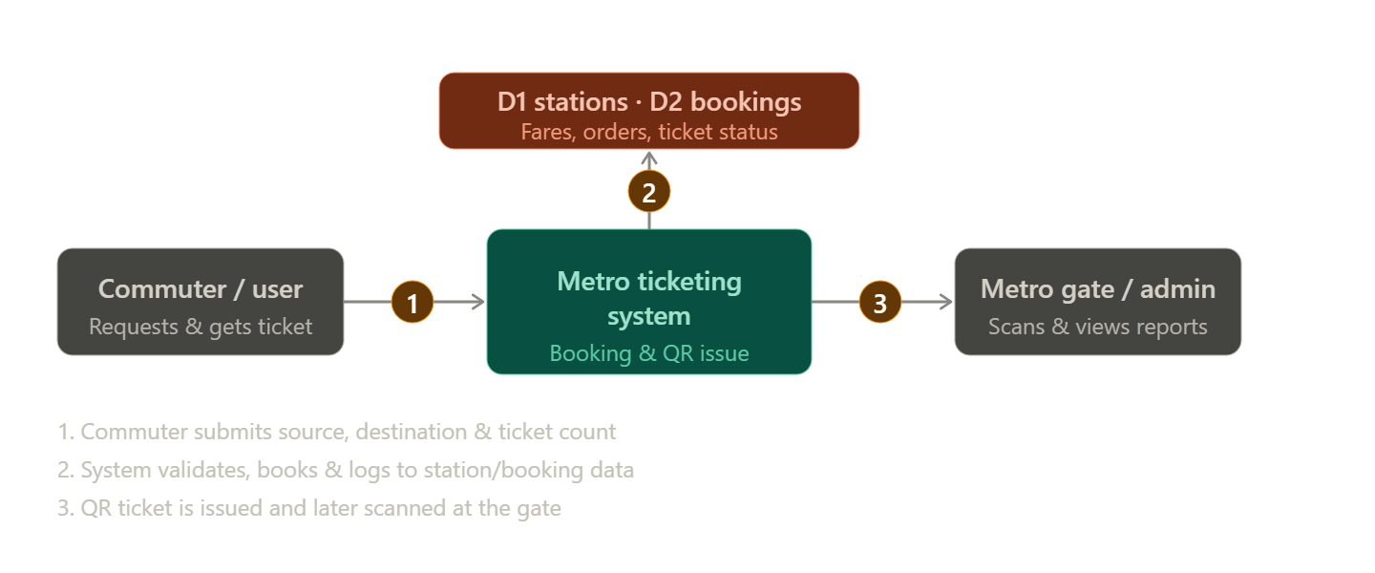

User Stories
Use the below template to list all the user stories for the product.
User Type | Functional Requirement (Epic) | User Story Number | User Story / Task | Acceptance Criteria | Priority | Release
Commuter | Ticket Selection | USN-1 | As a commuter, I want to select my Source and Destination stations from dropdowns so that I can specify my travel route. | System populates valid station names from u_metro_station without raw IDs. | High | Sprint-1
Commuter | Dynamic QR Generation | USN-2 | As a commuter, I want to view an instant QR code on my request form so that I can scan it at the gate. | HTML container renders a scannable QR code image upon selection. | High | Sprint-1
Commuter | Multi-Ticket Order | USN-3 | As a commuter, I want to specify the number of tickets so that I can book for multiple passengers at once. | Input field accepts positive integers and logs total quantity on ticket record. | Medium | Sprint-1
Admin | Automated Record Creation | USN-4 | As an administrator, I want submitted orders to automatically create records in u_metro_ticket_booking via Flow Designer. | Flow triggers on catalog submission and maps all user choices correctly. | High | Sprint-1
Admin | Ticket Status Tracking | USN-5 | As an administrator, I want to see real-time booking statuses so that active and used passes can be monitored. | Ticket record status defaults to 'Active' upon generation. | Medium | Sprint-2

